Chapter 8, Problem 61.

For the circuit in Prob. 8.5, find i and v for t > 0.

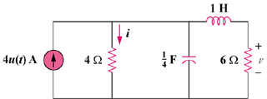

Figure 8.66
For Problem 8.5

